Four Channel
Digital Video Recorder
Model: DHV-450
Installation / User Manual

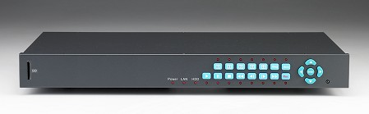

Version 1.0

Before attempting to connect or operate this product, please read this manual carefully and keep it for future use.
© Copyright 2006

WARNING
TO REDUCE RISK OF FIRE OR ELECTRIC SHOCK,
DO NOT EXPOSE THIS APPLIANCE TO RAIN OR MOISTURE.

CAUTION
DO NOT REMOVE COVER, EXCEPT FOR THE PURPOSE OF CHANGING HDD. IF IT IS NEEDED TO CHANGE HDD, PLEASE UNPLUG THE POWER FIRST BEFORE REMOVING THE COVER.
IN ANY OTHER CASES, PLEASE DO NOT REMOVE COVER, IT IS USER’S OWN RESPONSIBILITY IF ANY DAMAGE RESULTED FROM MOVING THE COVER.

CAUTION
REFER ALL WORK RELATED TO THE INSTALLATION OF THIS PRODUCT TO QUALIFIED SERVICE PERSONNEL OR SYSTEM INSTALLERS.

TABLE OF CONTENTS

1. Product Features 4
2. Part Names 5
2.1 Front Panel Keypads 5
2.2 Rear Panel 6
3. System Connection 7
3.1 Basic Connection 7
3.2 Optional Connection 8
4. General Operation 9
4.1 System Login 9
4.2 Live View 9
4.3 Video Quality Tuning 9
4.4 Search 10
5. Setup Menu 12
5.1 Main Menu 12
5.2 DATE/TIME MENU 13
5.3 CAMERA MENU 16
5.4 RECORD MENU 17
5.5 ALARM MENU 18
5.6 MOTION MENU 19
5.7 VLOSS/FAN FAULT MENU 20
5.8 NETWORK MENU 21
5.9 DISK MENU 27
5.10 COPY MENU 28
5.11 SYSTEM MENU 29
6. Specifications 31
Appendix A: Time Lapse Mode Recording Time 32
Appendix B: RS 232 Protocol 33

1. Product Features

- 4 CH cost-effective DVR
- 4 Camera inputs (NTSC/PAL)
- TV monitor out / Call (spot) monitor out
- MEPG4 compression with resolution up to
720 x 480 (NTSC) or 720 x 576 (PAL)
- Real time live display with total 120(NTSC)/100(PAL) fps
- Recording up to 120/100 fps for quad mode
- Quick start-up
- Quad or full-screen display
- On screen display menu operated by front buttons
- Search by date/time or event for playback
- RS232 port for local communication
- Ethernet TCP/IP connectivity for remote viewing and controlling
- SD card interface for retrieving the data in the HDD

2. Part Names

2.1 Front Panel Keypads



- Channel 1 full screen display
- Channel 2 full screen display
- Channel 3 full screen display
- Channel 4 full screen display
- Quad display/Sequence
- Search
- Setup Menu
- Arrow buttons
- SD card port
- Playback
- Pause
- Stop playback
- Fast reverse playback
- Step reverse playback
- Step forward playback
- Fast forward playback
- Rec. button
- Enter button

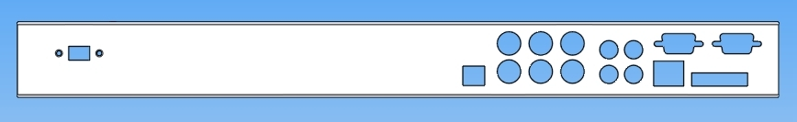
2.2 Rear Panel

- Main power plug (DC19V)
- Video input connectors 1 – 4
- Main monitor connector
- Audio in and out
- VGA connector (Optional)
- RS 232 connector
- Alarm in and out
- LAN connector
- Call monitor connector

3. System Connection
Main Monitor


Camera 1~4
Audio In/Out



VGA (Optional)
Power
RS 232

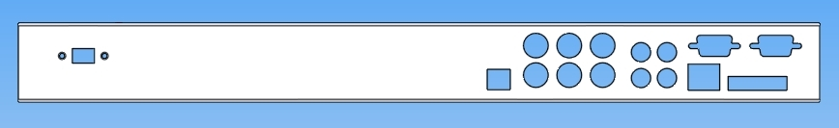



Alarm Out

Call Monitor
Alarm In

Internet

3.1 Basic Connection
- Cameras
Connect video input connector to the camera’s video output or other composite video source.

- Main Monitor
Connect the Main monitor output connector to a TV monitor. The TV monitor displays selected live or recorded cameras in any available format.

- Power
Plug the DC 19V power source into the power socket.

- Audio Input
The camera audio output or Microphone is connected to the audio input terminal at the rear panel.

- Audio Output
Connect the speaker or other audio listening devices to the audio output terminal on the back of the digital video recorder.

3.2 Optional Connection
- Call Monitor
Connect the Call monitor output connector to a TV monitor. This monitor displays the full screen image of cameras associated with alarms or images from the installed cameras sequentially.

- Alarm In
Connect Alarm In 4 inputs, Contact or TTL/CMOS signal polarity selectable.

- Alarm Out
N.C or N.O type alarm signal out.

- VGA (Optional)
Connect the VGA output connector to a VGA monitor. The VGA monitor displays selected live or recorded cameras in any available format.

- Controller Keypad
Connect remote controller keypad to RS232 port.

4. General Operation

4.1 System Login

To login the system, press “ENTER” button and enter the proper password by the numeric buttons (1-4) on the front panel. Press “ENTER” to confirm login. The password should be a 8-digit number and the default value is “11111111”.

4.2 Live View

- To view live images by static quad, press “Display” button.
- To view full screen of live image, press the desired channel button.
- To view sequential full screen display, press “Display” button twice.
Note:
- Please set the sequence time first in “Camera Menu”.
- Only the channel that has video input connected can be viewed with Sequence mode, meaning that at least 2 video inputs must be properly connected.

4.3 Video Quality Tuning

- Press channel button first to go into full screen of the desired channel.
- Press that channel button again to obtain Video Menu.
- Adjust Hue, Saturation, Brightness and Contrast of the channel by using direction arrows.

4.4 Search
This function is used to search the recorded data, by event or by time/date. Please press “Search” key to bring the following menu.

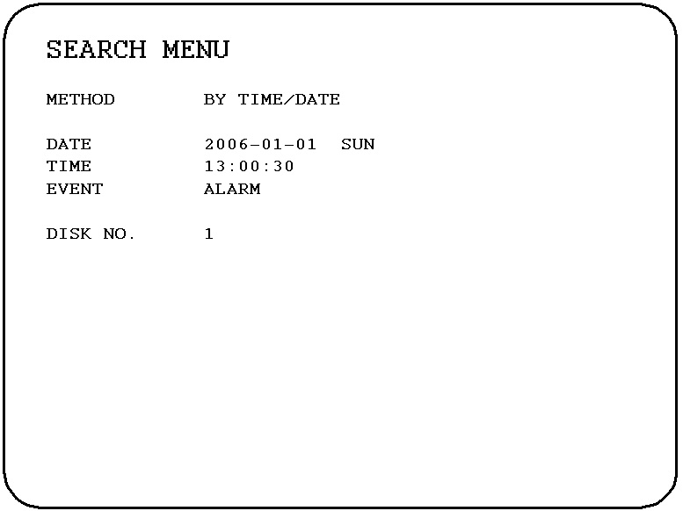

In the SEARCH MENU, we define:
There are two methods offered.
- Search by time/date: system will search the disk with user’s specified time and date. Press Enter key to confirm searching. While the specified point was found, system will jump there and play back automatically.
- Search by event: system search disk by event: (A)larm, (M)otion, V(loss) or their combinations (A/M, A/V, M/V, A/M/V). The system will search the event within the time selected. Press Enter key to confirm event searching and the following page will show up.

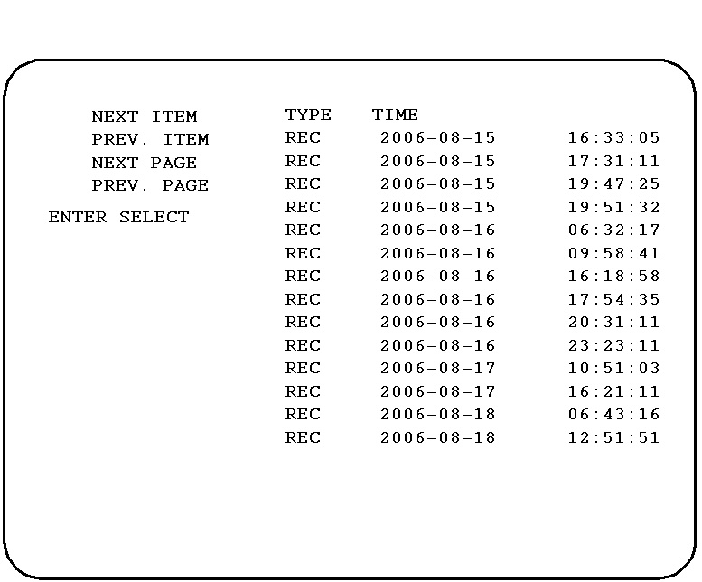

Press key for moving to next item of the same search page.
Press key for moving to previous item of the same search page.
Press key for moving to next page.
Press key for moving to previous page.
Press Enter key to confirm selection and the selected segment will be playing.

Disk NO.: Indicating the disk number.

Note: In order to quit the Search Menu, simply press Search key again to return to live view.

5. Setup Menu

5.1 Main Menu

Press Menu button, the Main Menu will be shown on screen as below.
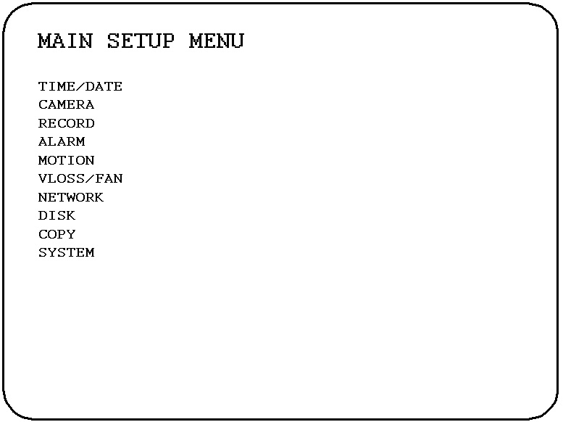

1. Press buttons to switch between items and to select parameter from the items.
2. Press “Enter” to enter the selected submenu.
3. Press “Menu” to return to the upper level.
4. Once the settings are completed, by pressing “Menu” button to exit from that page will validate the settings.

5.2 DATE/TIME MENU
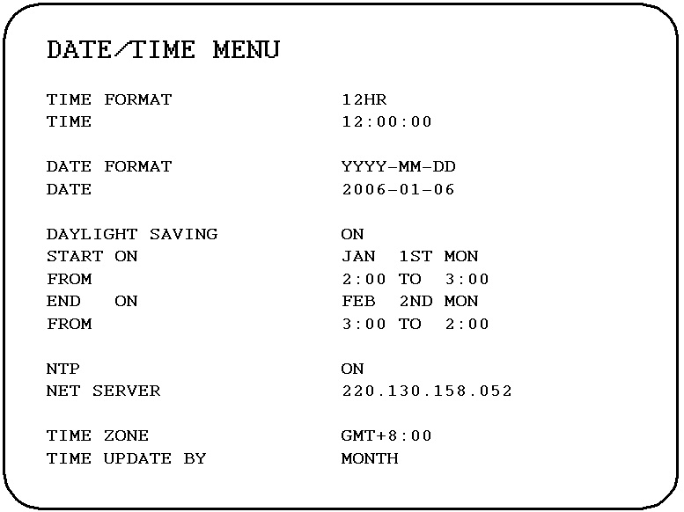

In the DATE/TIME MENU, we define:
- TIME FORMAT:
There are two time formats that are 12 HOUR and 24 HOUR to be selected.

- TIME: Current time
Hour: 00 ~ 23 (1 ~ 12 if TIME FORMAT is 12 HOUR)
Minute: 00 ~ 59
Second: 00 ~ 59

- DATE FORMAT:
There are three date formats which are YYYY-MM-DD, MM-DD-YYYY and DD-MM- YYYY to be selected.

- DATE: Current date
Date: 01~31 Month: 01~12 Year: 2000 ~ 2099 Day: Sun~Mon

- DAYLIGHT SAVING:
Select “ON” or “OFF” to enable or disable daylight saving time function.
In order to set a daylight saving time zone, you need to disable daylight saving first. Enable the daylight saving after you finish setting the time zone.

- START ON: To set the start time of daylight saving time.

To set the start month of daylight saving time: Use direction arrows to set the start month.
FEB
MAR
JAN
APR
MAY
JUN

DEC
NOV
OCT
SEP
AUG
JUL

To set the start week of daylight saving time: Use direction arrows to set the start week.
LAST
1 ST
2 ND
3 RD
4 TH

To set the start date of daylight saving time: Use direction arrows to set the start date.
THU
SUN
FRI
TUE
MON
WED
SAT

- END ON: To set the end time of daylight saving time.
To set the end month of daylight saving time: Use direction arrows to set the end month.
FEB
MAR
JAN
APR
MAY
JUN

DEC
NOV
OCT
SEP
AUG
JUL

To set the end week of daylight saving time: Use direction arrows to set the end week.

LAST
1 ST
2 ND
3 RD
4 TH

To set the end date of daylight saving time: Use direction arrows to set the end date.
THU
SUN
FRI
TUE
MON
WED
SAT

- NTP: Select “ON” or “OFF” to enable or disable NTP function.

NTP server: You can set the time server address where you locate if you connect to network and enable NTP. For checking the IP address of NTP Server, please follow the steps:
1. Connect your PC to the internet for searching the IP address of NTP server.
2. Go to “START” -> “RUN”, type “Command” and press “OK”
Under Dos Prompt, type “Ping Pool.NTP.ORG to find out the IP address of NTP Server.
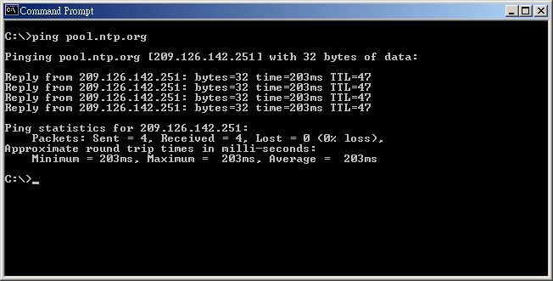

- TIME ZONE:

- TIME ZONE: You can set the time zone where you locate if you connect to network and enable time synchronize.

- TIME UPDATE BY:

Once you enable the NTP, the synchronization period can be set as one day, one week or one month.

5.3 CAMERA MENU
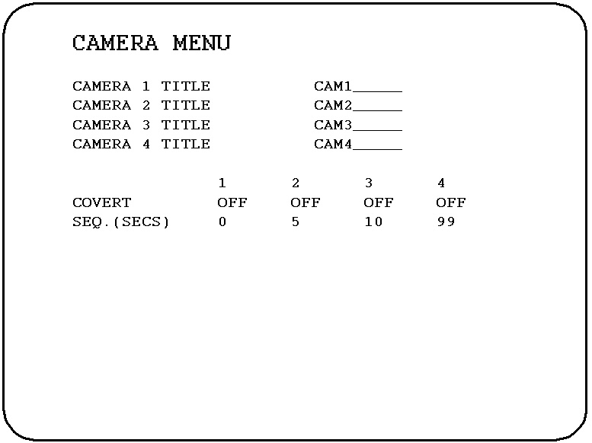

In the CAMERA MENU, we define:
- TITLE: The title setting allows you to assign a title to each camera input. Titling with 12 characters is supported in each channel. The available alphanumeric characters are:
0,1,2,3,4,5,6,7,8,9,
A,B,C,D,E,F,G,H,I,J,K,L,M,N,O,P,Q,R,S,T,U,V,W,X,Y,Z,a,b,c,d,e,f,g,h,i,j,k,l,m,n,o,p,q,r,s,t,u,v,w,x,y,z, ( ) . , + - / and an empty space.

- COVERT: Select “ON” to cover a camera, and disable the screen in live mode to show up. However, the image is recorded, and can be played back by user who has playback right. The covert channels will not show up on the sequence mode.

- SEQ. (SECS): Set the duration of sequence for each camera. Sequence duration can be set from 0-99 secs.

5.4 RECORD MENU
The Record Setup allows user to define the behaviors for recording operation.
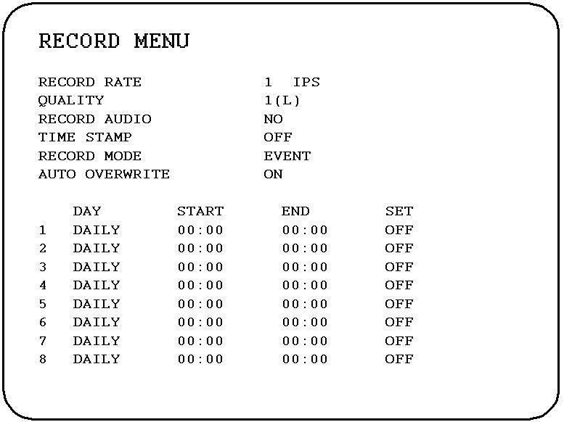

In the RECORD MENU, we define:
- Record rate: Select from 1,2,3,5,6,10,15 and 30 IPS for NTSC.
Select from 1,5,20 and 25 IPS for PAL.
- Quality: MPEG4 compression quality. Range from 1(L) the lowest to 5(H) the highest.
- Record Audio:
YES: Audio will be recorded when DVR is recording.
NO: Audio will not be recorded when DVR is recording.
- Time Stamp:
ON: Time stamp will show on the video and picture when recording.
OFF: Time stamp will not show on the video and picture when recording.
- Record Mode:
Event: The system starts to record when an alarm, motion or video loss event is triggered.
Manually: The system starts to record when you press “REC” key from the front panel, and it stops to record by pressing “ ” key.
Continuous: The system start to record automatically, it keeps recording even you press “ ” key.

Schedule: The system starts to record by scheduled time.
NOTE: This model has pre-alarm function. Pre-alarm time is set at 3 seconds for normal record quality (level 3). Record quality and complexity of image may influence pre-alarm time.

- Auto Overwrite:
Select “ON” for automatically overwriting the video when disk is full. Contrary, select “OFF” for non auto overwriting.

- Schedule Record:
The monitored image can be recorded according to the pre-set schedule.
There are 8 user-defined time segments available.
DAY: Select from Mon, Tue, Wed, Thu, Fri, Sat, Sun, Daily, Working Day (Mon~Fri) and Weekend (Sat~Sun).
START: Select the start time by using direction arrows.
END: Select the end time by using direction arrows.
SET: Select “ON” to enable time segment or “OFF” to disable it.

5.5 ALARM MENU
This ALARM page as below is used to configure the operation while alarm input occurs.
ALARM OUTPUT
CALL MONITOR
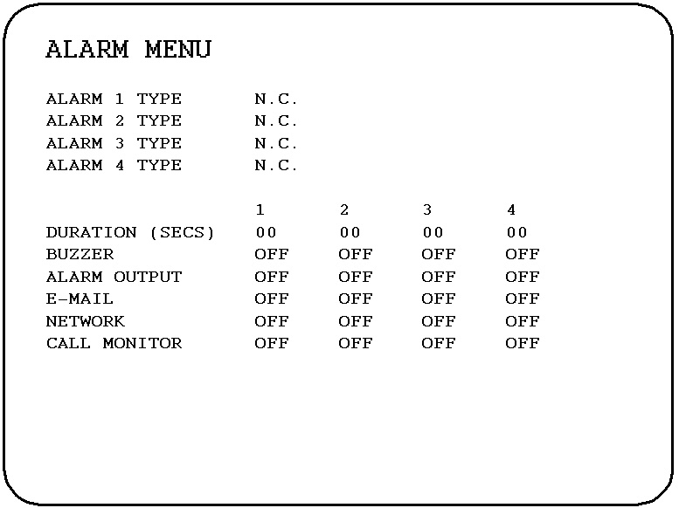

In the ALARM MENU, we define:
- Alarm type: can be set as N.C (Normal Close) or N.O (Normal Open)
- Duration (1-4): the time of buzzer’s output lasts
- BUZZER (1-4): Audible buzzer when alarm is detected.
ON: To enable an alarm buzzer.
OFF: To disable an alarm buzzer.
- Alarm output (1-4): turn on/off the alarm output of each channel
- E-mail (1-4): turn on/off the e-mail message delivery of each channel
- Network (1-4): turn on/off message delivery through network of each channel
- Call Monitor (1-4): turn on/off the call monitor display of each alarm channel.

5.6 MOTION MENU
This MOTION page is used to define the operations whenever there is moving object found on channel.
ALARM OUTPUT
CALL MONITOR
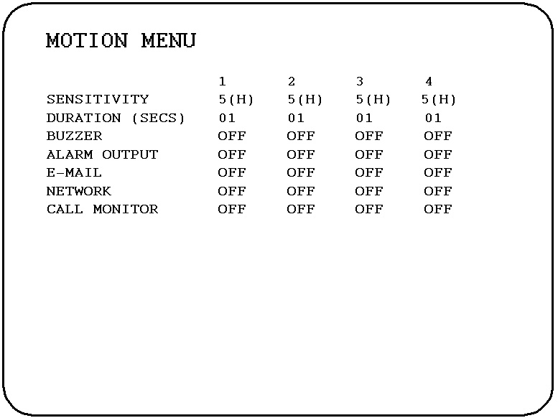

In the MOTION MENU, we define:
- Sensitivity: the sensitivity of motion detection, from level one (lowest sensitive) to level five (highest sensitive).
- Duration: the time of buzzer output lasts while moving object found.
- BUZZER: Audible buzzer when motion is detected.
ON: To enable a motion buzzer.
OFF: To disable a motion buzzer.
- Alarm output: turn on/off the alarm output while moving object found.
- E-mail: turn on/off the e-mail message delivery while moving object found.
- Network: turn on/off message delivery through network.
- Call monitor: turn on/off call monitor display.

5.7 VLOSS/FAN FAULT MENU
The VLOSS (video loss) and Fan Fault page is used to configure the operation while channels lost or fan error arose.
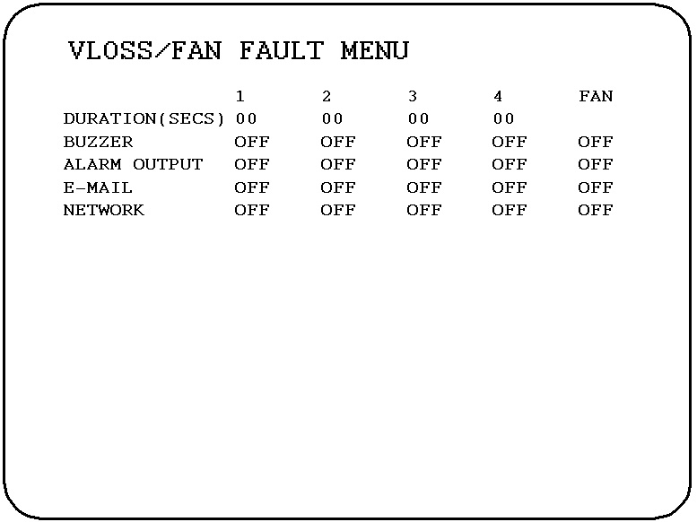

ALARM OUTPUT

In the VLOSS MENU, we define the following items for camera 1~4/ fan fault:
- Duration: the time of buzzer’s output lasts while channel lost occurs.
- BUZZER: Audible buzzer when Vloss/Fan fault is detected.
ON: To enable a Vloss/Fan fault buzzer.
OFF: To disable a Vloss/Fan fault buzzer.
- Alarm output: Turn on/off the alarm output while channel lost/fan fault occurs.
- E-mail: Turn on/off the e-mail message delivery while channel lost/fan fault occurs.
- Network: turn on/off message delivery through network while channel lost/fan fault occurs.

5.8 NETWORK MENU
In the NETWORK MENU, we define:

5.8.1 CONFIG

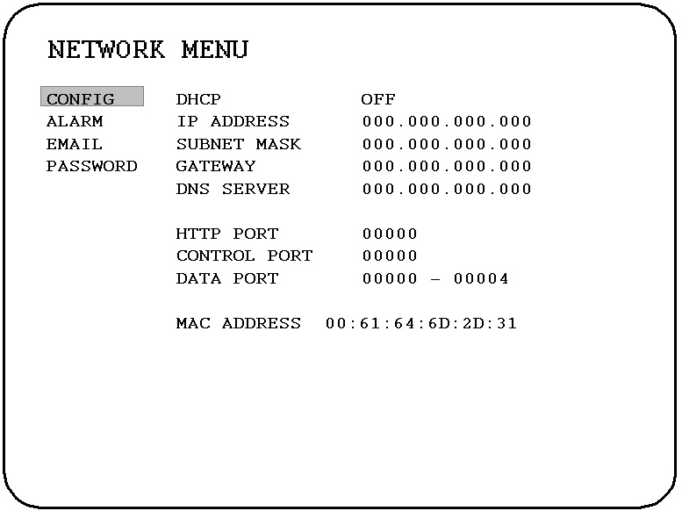

- IP CONFIG:
DHCP: DHCP server in LAN will provide the dynamic IP for network connection. If “OFF” is selected, then fixed IP will be used.
- IP Address: This field is to set a static IP Address for the DVR. A static IP address is an IP address whose value does not change. It is suggested to use a static IP address. If your Internet provider does not offer a static IP address you have the option to use a dynamic IP address. For Example: A Test IP address given to the machine by our engineers is 192.168.010.002. When DHCP is YES, the DHCP server will assign this value automatically.

- Note: The Addresses in the machine are for our own testing you must apply your own addresses to comply with your network. Refer to Networking Chapter for more details.

- SUBNET MASK: This field is to set the subnet mask for your network so as the DVR will be recognized within the network. Example: 255.255.255.000. When DHCP is YES, the DHCP server will assign this value automatically.

- GATEWAY: This field is to set the gateway for your network so the DVR will be recognized within the network. An example of this is provided within the DVR we use to test the machine within our own network. When DHCP is YES, the DHCP server will assign this value automatically.

- DNS SERVER: This field is to set the DNS server for your network so the DVR will be recognized within the network. An example of this is provided within the DVR we use to test the machine within our own network. Assign a DNS server to DVR, for example: 168.195.001.001. When DHCP is YES, the DHCP server will assign this value automatically.

- HTTP PORT: User can change it to different port number for HTTP/WEB communication between DVR and client PC.

- CONTROL PORT: User can change it to different port number for controlling comment between DVR and client PC.

- DATA PORT: User can change it to different port number for data transfer between DVR and client PC.
Note: If you wish to have multiple users log into the DVR please open a range of ports on your router. For example if you use the port 32760 you would open ports 32760-32761 on your router. This will allow 2 clients to login.

- MAC ADDRESS: This field is for those Internet service providers or Network administrators who require a MAC address of the network card of our DVR. This option cannot be changed.

5.8.2 ALARM
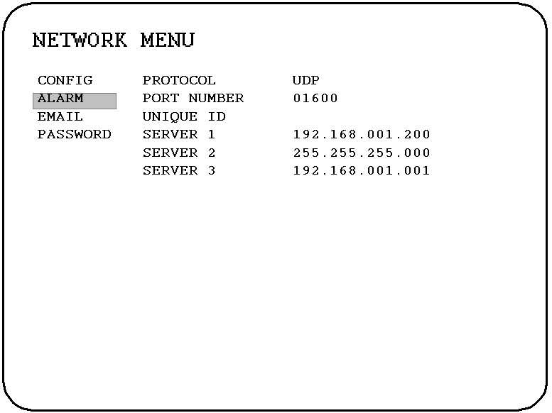

Note: Since every Network Configuration is different, please contact your Network Administrator or ISP for how to assign the IP addresses and port numbers.
- PROTOCOL: Select which communication protocol with Alarm servers or Alarm receiving clients.

TCP: communicate with client via TCP protocol.
UDP: communicate with client via UDP protocol
- PORT NUMBER: setting the communication port with Alarm server.

- UNIQUE ID: setting the ID number of your DVR to Alarm server.

- SERVER 1: assign the IP address of Alarm server 1.

- SERVER 2: assign the IP address of Alarm server 2.

- SERVER 3: assign the IP address of Alarm server 3.

5.8.3 E-MAIL
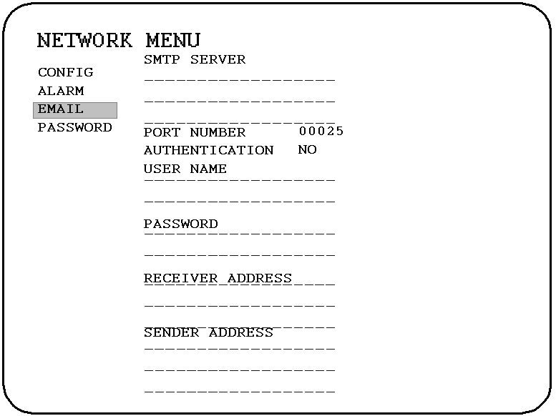

- SMTP SERVER: assign the SMTP (e-mail) server’s address or your email servers IP address.

- PORT NUMBER: assign the port number for SMTP server.

- AUTHENTICATION: select “YES”, if the SMTP server requires Authentication (user name / password)

- USER NAME: Input the login user ID if the SMTP server requires Authentication.

- PASSWORD: Input the password if the SMTP server requires Authentication.

- RECEIVER ADDRESS: Input receiver’s e-mail address for the e-mail message to be received when an EVENT is enabled and triggered. For example: In Motion Menu, if the “E-MAIL” is set to “ON”, this e-mail address will receive a text message when Motion is triggered.

- SENDER ADDRESS: Input sender’s e-mail address, so that receiver can recognize the sender when an event message is sent out.

5.8.4 PASSWORD
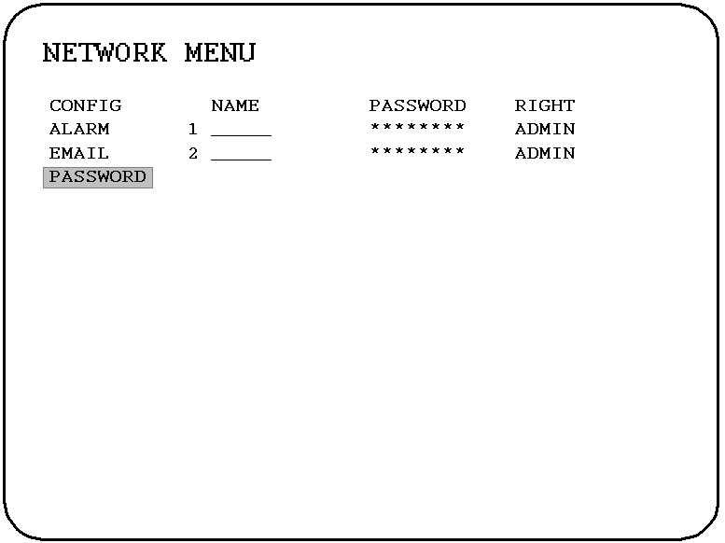

- User-Name/Password/Right: This category is to set up the users that will log into the network. Please remember that this portion of the Network setting menu is set up in column format.
The default User Name = admin
The default Password = 11111111 (only numeric)
- There are 3 types of right:
- Admin: Allows the user to view live video, perform a search, playback and control a PTZ camera (if one is connected)
- Operator: Allows the user to playback the last recorded video
- Guest: Allows the user only to view live video

- Example: USER-NAME Password Level
admin 11111111 Admin
Changed to Adam 22222222 Admin

5.9 DISK MENU
This page is the configuration for hard disk drive related function.
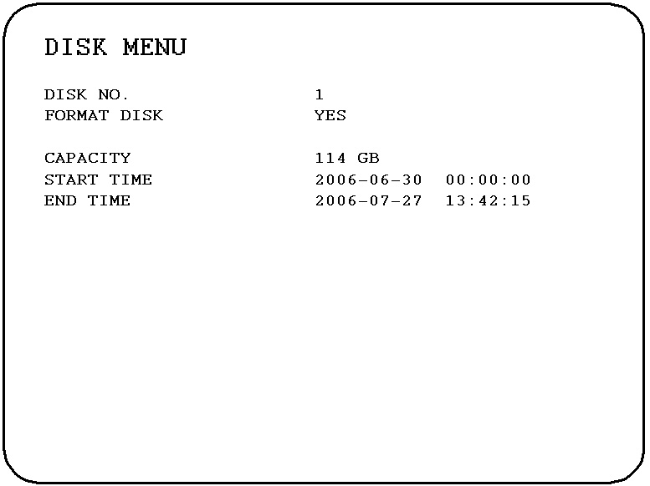

In the DISK MENU, we define:
- Disk No.: Indicating the disk number.
- Format Disk: Select “Yes” to format the target disk. Select “No” for not formatting the disk.
The followings are Disk information provided, not to be selected or changed:
- Capacity: Capacity of the selected disk.
- Start Time: Start time of the first recorded video.
- End Time: End time of the latest recorded video.

5.10 COPY MENU
The COPY function is used to retrieve the recorded data in disk. Users specify their preferred segment and the target media where it will be saved to.
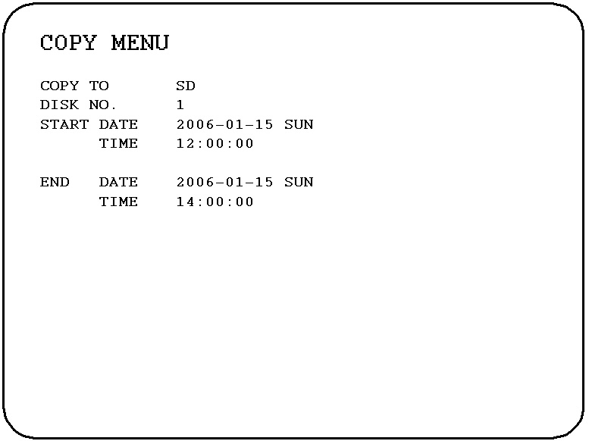

In the COPY MENU, we define:
- COPY TO: SD card, the target media where the recorded data will be saved to.

- Disk NO: Indicating the disk number.

- START DATE & TIME: The start date and time of video you wish to copy.
- END DATE & TIME: The end date and time of video you wish to copy.

5.11 SYSTEM MENU
This page shows up the system information such as firmware version and input video standard. User can also set up the password, upgrade firmware or configuration file here.
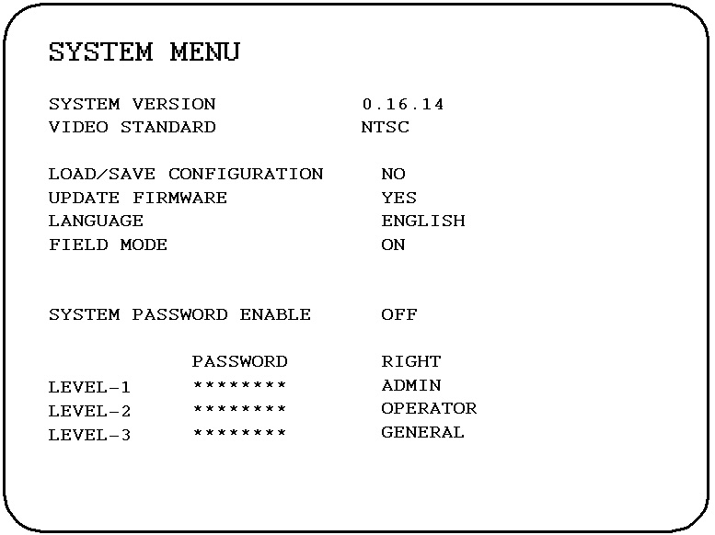

In the SYSTEM MENU, we define:
- System version: Indicating current system version. NTSC or PAL.
- Video standard: NTSC/PAL. If the system version is PAL, then 3 options are available to be chosen:
PAL (B/D/G/H/I)
PAL (M)
PAL (N)
- Load/Save configuration: Select “YES” to enter the selection window, there are 4 options available: LOAD, SAVE, DEFAULT and CANCEL. Select “LOAD” to upload and save DVR configuration settings from SD card. Select “SAVE” to save existing DVR configuration settings to SD card. Select “DEFAULT” to load factory default values. Select “CANCEL” for leaving the existing window. Note that a SD card has to be inserted properly before choosing “LOAD” and “SAVE” options. Please stop recording if you confirm to load default setting, to load saved setting or to save existing setting when the system is recording.
Select “NO” for not loading or saving configuration.

- Update Firmware: administrator can upgrade firmware from SD card by selecting “Yes”. System will be rebooted before updating, therefore please make sure first if you really need to update firmware.

- Language: please select either English or Chinese for software language.

- Field Mode: ON/OFF
Usually, it is recommended to select Field Mode “OFF” which is equivalent to Frame mode; that gives you a real resolution of the images. However, if the movement is too fierce, then switch Field mode to “ON” would be a better choice in order to obtain a clear freeze-frame.

- Three-level priority is provided to secure the system integrity.

General user: has the right to switch video channels.
Operator: has the same right as general user + playback right. Video can be played back by pressing “Play” button. System starts to play from the last played point.
Administrator: full functioned user.

6. Specifications
No | Item | Description
1 | Video Format | NTSC/EIA or PAL/CCIR DIP switch selectable
2 | Video Input | 4 camera inputs (BNC), 1Vp-p/75ohm
3 | Video Output | Main Monitor: 1 BNC composite video output, 1Vp-p/75ohm
3 | Video Output | Call Monitor: 1 BNC composite video output, 1Vp-p/75ohm
4 | Video Compression | MPEG4
5 | Video Resolution | (Quad Recording) NTSC: Full-D1
5 | Video Resolution | (Quad Recording) PAL: Full-D1
6 | Video Display | Quad or full screen display
7 | Display Resolution | 720x480 (NTSC) or 720x576 (PAL)
8 | Video Pause | Yes
9 | Alarm Inputs | 4 inputs, Contact or TTL/CMOS signal polarity selectable
10 | Alarm Outputs | 1 Normally Open or Normally Closed relay output
11 | Hard Disk Storage | One 3.5" hard disk
12 | Recording Rate | Up to 120/100 Images per second for NTSC/PAL
13 | Recording Mode | Normal, Schedule Rec.
13 | Recording Mode | Event recording (Motion, Video Loss, Alarm)
14 | Playback Rate | Up to 120/100 Images per second for NTSC/PAL
15 | Playback Search | By Date/Time or Event (Motion, Alarm)
16 | Motion Detection | 5-level configurable sensitivity and motion set-up for each camera
17 | Video Loss Detection | Yes
18 | User Interface | User friendly menu driven
19 | Setup | On screen display setup
20 | Timer | Built-in real time clock and Auto Time Synchronization with global
21 | Watch Dog Timer | Yes
22 | Title | 12-character title generator for each camera
23 | Ethernet | Yes, RJ45 connectors for network communication
24 | Archive | Compact SD Card
25 | RS-232 | 9-pin female connector for local communication
26 | Audio | 2 mono input, 2 mono (SPEAKER) output
27 | Power Source | DC19V
28 | Power Consumption | 110W
29 | Dimension | 438W x 262D x 44H mm
30 | Weight | 4.4 KG
31 | Operating Temperature | 0 °C ~ + 40 °C
32 | VGA output | Optional
33 | Playback | Play, pause, stop, step forward/backward, 4-level fast forward/backward
34 | Certification | CE, FCC

Appendix A: Time Lapse Mode Recording Time

Quad recording Mode (Total HDDs’ storage: 120GB)
Estimated with typical image based on mid-resolution cameras – low noise level

NTSC | Record Quality
NTSC | 5(High) | 4 | 3 | 2 | 1(Low)
Total Capture Rate(IPS) | Recording Time (Hours)
30 | 85.71 | 98.36 | 115.38 | 137.93 | 173.91
15 | 131.87 | 151.32 | 177.51 | 212.20 | 267.56
10 | 152.16 | 174.60 | 204.82 | 244.85 | 308.72
5 | 234.09 | 268.62 | 315.12 | 376.69 | 474.96
1 | 900.33 | 1033.16 | 1211.98 | 1448.80 | 1826.75
PAL | Record Quality
PAL | 5(High) | 4 | 3 | 2 | 1(Low)
Total Capture Rate(IPS) | Recording Time (Hours)
25 | 94.49 | 104.35 | 116.50 | 139.53 | 176.47
20 | 107.37 | 118.58 | 132.39 | 158.56 | 200.53
5 | 215.04 | 237.48 | 265.15 | 317.56 | 401.62
1 | 827.07 | 913.38 | 1019.79 | 1221.38 | 1544.68

Terms of Use
The HDD size required in your DVR may vary from this calculated test result under some conditions. Total storage capacity may vary depending on complexity of video scenes, DVR specifications and features used on the actual installation sites. Test results and information obtained from these tables are furnished for informational use only. It is user's responsibility to test and allocate appropriate HDD size for his/her DVR systems.

Appendix B: RS 232 Protocol

Communication |  | RS-232
Baud Rate |  | 9600 BPS
Data Bits |  | 8 Bits
Stop Bit |  | 1 Bit
Parity |  | None
Data Format |  | Word 1 – Length Byte  Word 2 - High Order Address Byte  Word 3 - Low Order Address Byte  Word 4 – Opcode Byte  Word 5 - Data 1 Byte  Word 6 - Data 2 Byte  Word 7 - Data 3 Byte (used with Opcodes 5 and 8 Only)  Word 8 – CheckSum Byte(Sum of all previous byte , logical AND sum with 7F hex)
Used Command (HEX)
Key | Word1 |  | Word2 | Word3 | Word4 | Word5 | Word6 | Word8
UP | 0x86 |  | 0x00 | 0x00 | 0x02 | 0x08 | 0x00 | 0x10
Down | 0x86 |  | 0x00 | 0x00 | 0x02 | 0x00 | 0x08 | 0x10
Left | 0x86 |  | 0x00 | 0x00 | 0x02 | 0x10 | 0x00 | 0x18
Right | 0x86 |  | 0x00 | 0x00 | 0x02 | 0x00 | 0x10 | 0x18
Enter | 0x86 |  | 0x00 | 0x00 | 0x07 | 0x00 | 0x00 | 0x0D
CH1 | 0x86 |  | 0x00 | 0x00 | 0x07 | 0x11 | 0x00 | 0x1E
CH2 | 0x86 |  | 0x00 | 0x00 | 0x07 | 0x21 | 0x00 | 0x2E
CH3 | 0x86 |  | 0x00 | 0x00 | 0x07 | 0x31 | 0x00 | 0x3E
CH4 | 0x86 |  | 0x00 | 0x00 | 0x07 | 0x41 | 0x00 | 0x4E
Quad | 0x86 |  | 0x00 | 0x00 | 0x07 | 0x51 | 0x00 | 0x5E
SEQ | 0x86 |  | 0x00 | 0x00 | 0x07 | 0x02 | 0x00 | 0x0F
Menu | 0x86 |  | 0x00 | 0x00 | 0x07 | 0x03 | 0x00 | 0x10
Play | 0x86 |  | 0x00 | 0x00 | 0x07 | 0x04 | 0x00 | 0x11
Pause | 0x86 |  | 0x00 | 0x00 | 0x07 | 0x05 | 0x00 | 0x12
Stop | 0x86 |  | 0x00 | 0x00 | 0x07 | 0x07 | 0x00 | 0x14
RFast | 0x86 |  | 0x00 | 0x00 | 0x07 | 0x08 | 0x00 | 0x15
RStep | 0x86 |  | 0x00 | 0x00 | 0x07 | 0x09 | 0x00 | 0x16
FStep | 0x86 |  | 0x00 | 0x00 | 0x07 | 0x0A | 0x00 | 0x17
FFast | 0x86 |  | 0x00 | 0x00 | 0x07 | 0x0B | 0x00 | 0x18
Rec | 0x86 |  | 0x00 | 0x00 | 0x07 | 0x0C | 0x00 | 0x19

